Newsletter Content for Publication - Option 1

The Pennsylvania Turnpike Commission (PTC) aims to become America’s First Sustainable Superhighway by 2040.

Recently, the PTC published its annual Sustainability Report, the culmination of a three-year, intensive focus on driving the PTC past green into sustainable and ultimately restorative practices across our 550+ mile toll road operation.

The pursuit of excellent stewardship led to several, significant accomplishments. In 2022, The Pennsylvania Turnpike Commission became the first state agency to receive a 100% GreenGov score by incorporating sustainability in its policies, planning, operations, procurement, and regulatory functions.

In a tolling industry first, its first solar microgrid came online in Greensburg. Alongside a continuous, natural gas-powered generator, the microgrid is projected to yield $450,000 in annual savings, a new revenue stream and eventual energy independence.

Construction continued on a 500-mile fiber optic cable network that will power enhanced mobility and access upgrades across the Pennsylvania Turnpike, including Open Road Tolling (ORT). Additionally, broadband connectivity opportunities will be extended to underserved areas along the roadway, helping bridge the digital divide.

2020’s conversion to cashless payment (e.g., All Electronic Tolling) reduced the PTC’s carbon footprint by 45%, or approximately 65 tons of CO2 emissions per year. By 2030, upon full implementation of ORT, a further annual reduction of 7%, or 11 tons, is predicted.

Finally, the PTC continued to prepare for the anticipated electric vehicle surge, increasing its EV charging stations from 55 to 63 across its system. By 2027, the PTC aims to have at least 80 across all service plazas.

Want to learn more about partnering with the PTC to find sustainable solutions for your community? Email Sustainability@paturnpike.com.

Newsletter Content for Publication - Option 2

The Pennsylvania Turnpike Commission (PTC) aims to become America’s First Sustainable Superhighway by 2040.

Recently, the PTC published its annual Sustainability Report, the culmination of a three-year, intensive focus on driving the PTC past green into sustainable and ultimately restorative practices across our 550+ mile toll road operation.

Highlighted accomplishments include:
- Becoming first state agency to achieve a 100% score from the GreenGov Council.
- Bringing its first solar microgrid – a tolling industry first – online in Greensburg.
- Continuing to lay a 550-mile fiber optic network.
- Preparing for Open Road Tolling.
- Constructing gantries for Open Road Tolling and contracting to place 80 EV chargers across our system by 2027.

Want to learn more about partnering with the PTC to find sustainable solutions for your community? Email Sustainability@paturnpike.com.

Social Media Posts for Public Use

Suggested Post 1
The GreenGov Council was established by Gov. Tom Wolf in 2019. Run by the Pennsylvania Department of General Services, it strives to help the state reach its climate goal of an 80% net reduction in greenhouse gas emissions by 2050. The Pennsylvania Turnpike Commission became the first state agency to receive a 100% GreenGov score by incorporating sustainability in its policies, planning, operations, procurement and regulatory functions. Learn more at https://www.paturnpike.com/responsibility-matters/sustainability. #InvestinOurPlanet

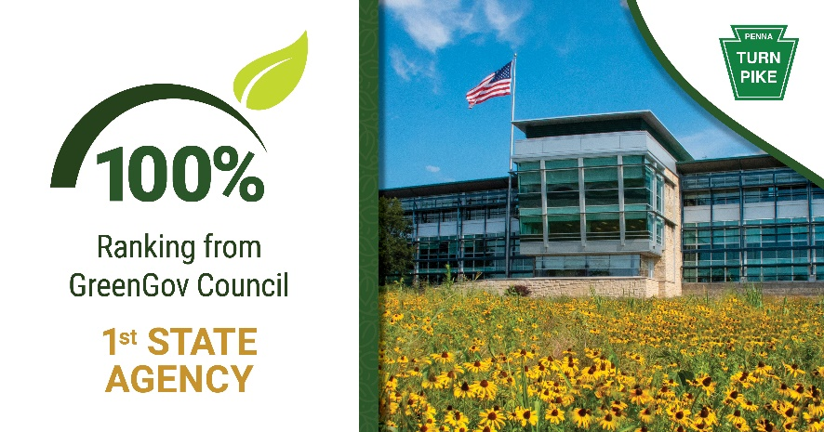

Suggested Post 2
Energy efficient and resilient, a 550-mile fiber optic cable network will power enhanced mobility and access upgrades across the Pennsylvania Turnpike. Additionally, broadband connectivity opportunities will be extended to underserved areas along the roadway, helping bridge the digital divide. Learn more at https://www.paturnpike.com/responsibility-matters/sustainability. #InvestinOurPlanet

Suggested Post 3
In a tolling industry first, the Pennsylvania Turnpike Commission brought its first solar microgrid online in Greensburg. Alongside a continuous, natural-gas powered generator, the microgrid is projected to yield $450,000 in annual savings, a new revenue stream and eventual energy independence. Additional solar projects, including a canopy to power electric vehicle recharging stations and solar field to supply maintenance and office buildings, are planned for the coming years. Learn more at https://www.paturnpike.com/responsibility-matters/sustainability. #InvestinOurPlanet

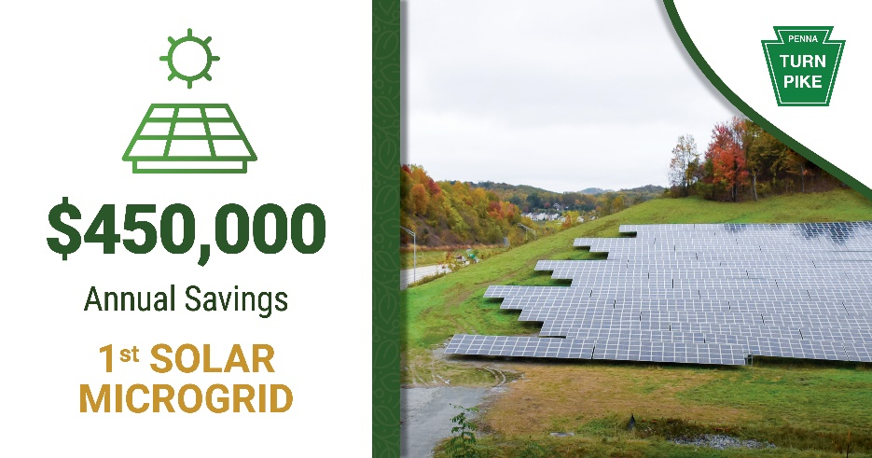

Suggested Post 4
Over the next two decades, the Pennsylvania Turnpike Commission will integrate solar, fiber, inductive charging, connected vehicle technology, buried electric transmission lines, and other innovation to give its users a complete customer experience by increasing mobility and traffic flow, reducing congestion, and decreasing the carbon footprint. Learn more at https://www.paturnpike.com/responsibility-matters/sustainability. #InvestinOurPlanet

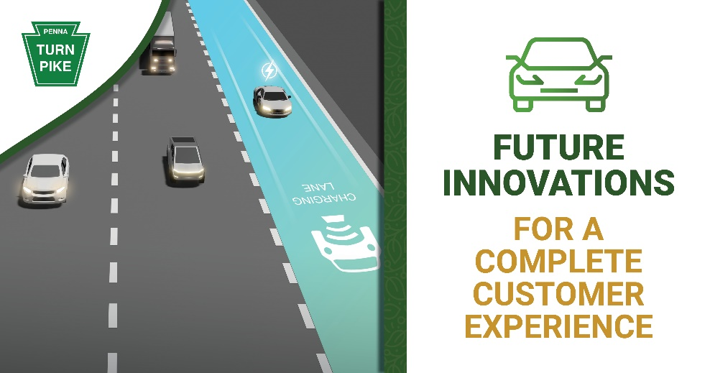

Suggested Post 5
In the U.S., native bees contribute at least $3 billion to crop pollination annually. With almost 90% of plant species requiring pollinator assistance, environmental protection is crucial. A series of pilot pollinator habitats are being tested across the Pennsylvania Turnpike. Native plants bloom in place of grass, providing winter safe nesting while reducing pesticide runoff and lawn mower-generated fossil fuel emissions. Learn more at https://www.paturnpike.com/responsibility-matters/sustainability. #InvestinOurPlanet
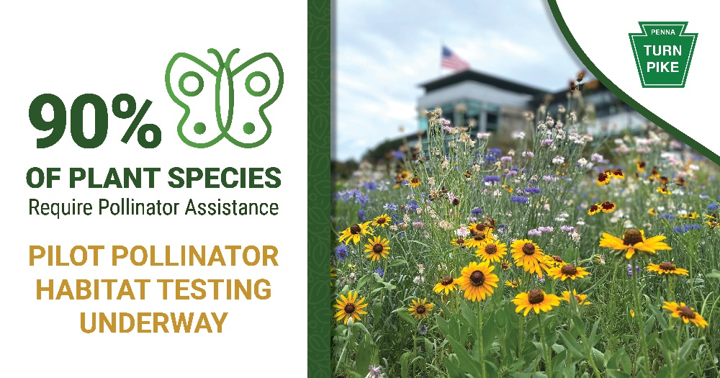

Suggested Post 6
By 2040, electric vehicles could make up 57% of all passenger car sales worldwide, according to BloombergNEF. The Pennsylvania Turnpike is prepared, with 63 EV charging stations deployed across its system and more to come. In 2029, it will test in-road or inductive charging along a section of the Mon/Fayette Expressway, helping ease barriers to long-distance EV travel. Learn more about the project at https://www.paturnpike.com/responsibility-matters/sustainability. #InvestinOurPlanet

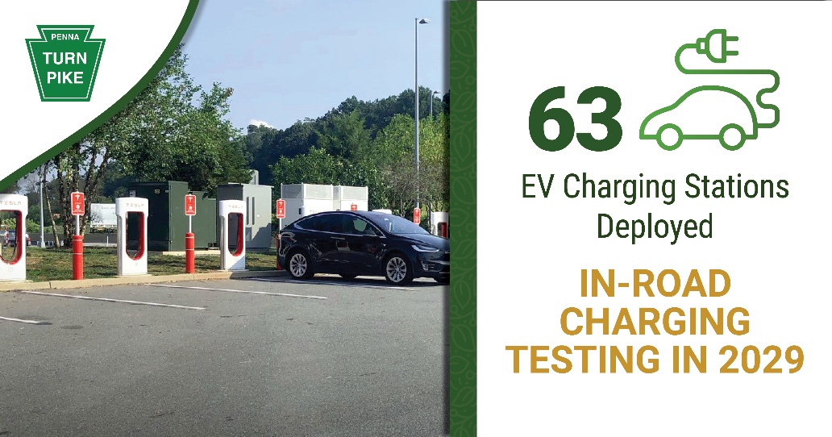

OP-ED FOR PUBLICATION

Sustainable is Attainable: Environmental Responsibility at the Pennsylvania Turnpike
By Mark Compton
Chief Executive Officer

The Pennsylvania Turnpike Commission (PTC) believes that creating a sustainable future is the right thing to do – for our customers, partners, and planet.

Sustainability can be considered “nice to have;” however, it’s increasingly clear that sound environmental decisions bring multiple benefits.

Here’s a real-life example. Consider your home’s electric bill. It’s higher than you’d like and the whole family needs to be more mindful. We parents know how kids can walk out of rooms with lights on and TVs blaring. Imagine if they shut them off each time we asked! There’d likely be noticeable savings on the next bill. The right thing to do financially is also environmentally responsible.

The PTC, like private sector employers, receives no tax dollars. Our expenses are offset by revenue – primarily tolls. For decades, conservative financial management served us well. Then, in 2007, Act 44 obligated us to redirect $450 million each year to PennDOT, requiring loans and annual toll increases to shore up credit ratings. Payments were reduced in 2022, though debt service continues. Addressing a burden that large required full organizational participation.

By the 2010s, we were making sustainable changes, such as swapping halogen lights with money-saving LEDs and constructing energy-efficient buildings using green design principles.

In 2020, we created the PTC’s Sustainability Committee. A group of dedicated employees drive the strategy to ensure all projects are reviewed for economic, environmental, and social impacts using the United Nations’ 17 Sustainable Development Goals and Pennsylvania’s GreenGov Council standards. As a result, the PTC was the only state agency to earn a 100% from the GreenGov Council. It also produced the second annual Sustainability Report, providing an overview of our efforts and impact.

Drivers choose to take the Pennsylvania Turnpike, so sustainability also means creating conditions that encourage that decision for decades ahead.

Last year, the PTC reached a milestone when its first solar microgrid came online in Westmoreland County. Solar energy powers the multi-building maintenance facility campus in Greensburg, alongside a natural gas-run continuous generator. The microgrid provides energy independence, a new revenue stream as excess power is sold back to First Energy, and $450,000 in annual utility savings. This success propelled exploration of solar opportunities across our system. Two additional microgrid locations are planned and a solar canopy will be installed at the Middletown Central Administration Building (CAB).

The coming years will bring a surge in electric vehicle (EV) use. With 63 EV charging stations already installed at our service plazas, that number will grow as we partner with PennDOT and the Federal Highway Administration to leverage funding released under the Bipartisan Infrastructure Law and Inflation Reduction Act.

In March, I spoke at a legislative hearing on the Drive Smart Act, which would fund highway maintenance by applying mileage-based user fees to EVs. There, I noted our largest customers, delivery services, see inductive charging as driving commercial trucking’s future. This technology replenishes electric vehicles via pavement-embedded coils that signal on-board receivers. Successful implementation would revolutionize how people and goods transverse the country.

The PTC’s planned 2029 inductive charging pilot along a section of the Mon/Fayette Expressway dovetails with the future needs of critical transportation partners, further illustrating that “sustainable” is environmentally and financially beneficial.

Closer to home, starting in 2024, the Commission will offer stationary inductive charging stations at the CAB, allowing its EV fleet to recharge while parked at terminals drawing energy from the solar canopy.

Sustainable change isn’t empowered by large projects alone; tweaking everyday tasks and routine processes can make an impact.

At the PTC, water bottle refilling stations have saved thousands of plastic bottles from landfills while pollinator gardens are reducing mowing schedules, encouraging winter nesting of bees and lessening pollution associated with pesticide runoff and lawn mower fossil fuel emissions.

Compliance with state and federal practices around stormwater management used to be a labor-intensive, paper-based activity. In 2021, we launched the Documentation Inspection Reporting Technology (DIRT) app to streamline workflows. As a result, we’re on track to save 2,300 staff hours and $204,300 each year.

For more than 80 years, The Pennsylvania Turnpike Commission has proudly operated “America’s First Superhighway,” which surmounted physical progress barriers of the 1940s. As we drive toward becoming its first Sustainable Superhighway by 2040, the PTC is preparing for the next generation of transportation needs that will protect resources and our roadway for years to come.

